Big things I’ve worked on:

1. Analyzing performance trade-offs were I to build an entirely new aircraft. Looking at some of these numbers and the general shape of Muse, I think this would be the way to go if I wanted to...break a world record or something. Just a thought.

If you’re curious, This is the link to my most recent analysis. I have other versions too, such as with Li-ion power, with solar etc. Let me know if you’d like to see those. There’s lots of interesting stuff in that analysis, but be sure to check out the “performance calculator” tab. I arbitrarily downsized the aircraft from 126” WS to 100” WS. This is largely for my own sake, were I to make such a thing, it would be cheaper. I made assumptions about the mass of the airframe and motors decreasing proportionately also. As of the time of this writing, I just recently added functionality for estimating the performance of a gas-hybrid-electric generator. Currently it is set up to assume ~300W power produced at ~15% thermodynamic efficiency and fuel that is 90% by mass (10% oil). The aircraft currently assumes a Lift/Drag ratio of ~12 during its best cruise condition. I am optimistic that at least that would be achievable with the right configuration. I am skeptical, however, that my mass and efficiency estimations would scale down that well for the engine/generator. I also did not account for the loss of motor/propeller efficiency with increasing airspeed, but I don’t think it will be a terrible deal breaker at our speeds. This model is likely on the optimistic side, but it still suggests that you could (with no payload) fly such a vehicle for over 24 hours or 1000 miles. That is with no power from solar panels. I.e. flying at night. This model also presently does not account for the decreasing mass of the aircraft under a hybrid-electric system. This would, in theory, improve performance. With the solar panels from Alta Devices (were they still functioning), you could probably double your flight time during the day (based on their claims, I calculated up to 3.9 W from a cell of the size that we had on Muse).

2. Coming up with a new Motor-Mounting Scheme on the original aircraft. As mentioned, this design is belt driven. I know the image looks like carbon fiber, but I’d be using fiberglass (at least in the near-term). I’m still sorta at a loss on how to responsibly transfer the torque through the stock wing-center without rebuilding it with twin spars or having a very precise pin that goes through the stock CF spar. Former could be heavier and requires re-building wing center, but the latter has considerable manufacturing challenge and may not work long-term.
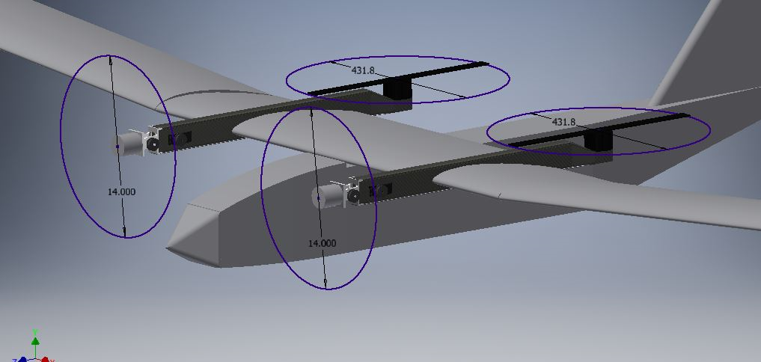
A model of the new motor-mounting-arms attached to Muse.
2.1 Test-prototype of that mechanism works just fine so far. If you didn’t see it, I included a short clip of it in action with the email I sent you. I removed most of the slop, and it could work just fine. It has mechanical stops at both ranges of its operating envelope (vertical and horizontal/forward), and so far it has passed all structural load testing I have subjected it to. I would like to look at using a worm-gear instead, but that's challenging without metalworking equipment. Along with that also goes a desire to use aluminum, but without the equipment, that would cost lots of money to get it made. I might also look at a direct-drive mechanism later, but I kinda think it’s better to keep moving right now.
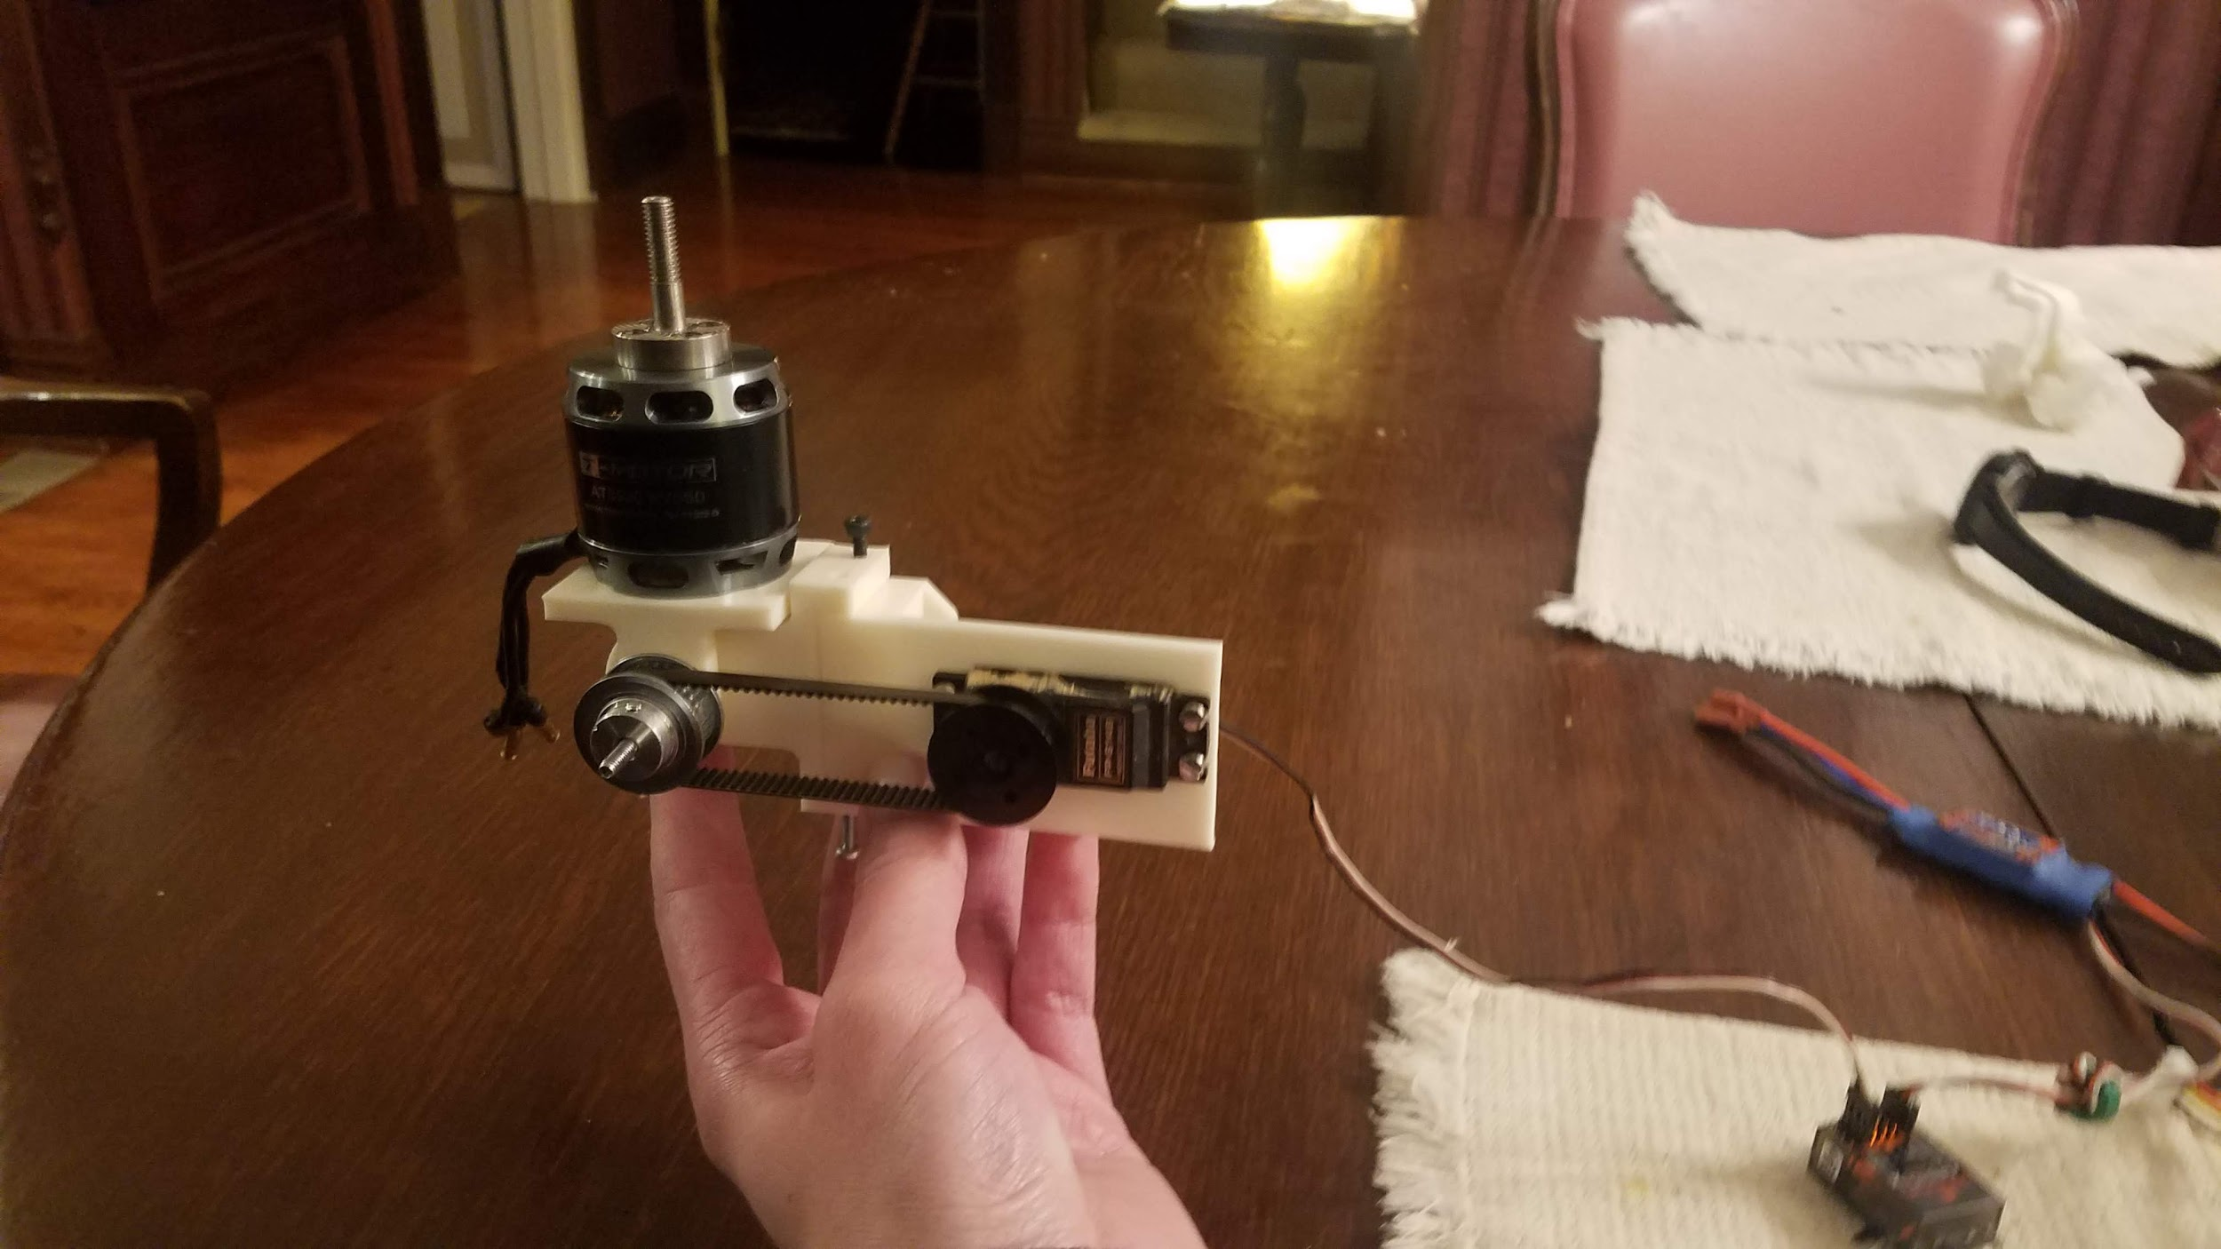
Just an image of the current VTOL motor mount iteration test setup. Looking closely, you can see where the black and silver (respectively) M3 screws join the motor mount assembly to the 3d-printed motor-mount-arm stand-in.

3. Load testing a large foamboard aircraft I have.
I crashed this airplane last week, and I figure I could use it as a low-risk hover, transition, and controls test platform. I did some basic load testing with the original motors, ESCs, and motor-mount arms just to get an idea whether the aircraft's wing structure could handle the weight. It flexed a lot, and parts of the top surface were in danger of buckling. I think with a thin layer of fiberglass reinforcement, it will work fine. The aircraft will likely fly with a 5S lipo battery that I have. This is smaller than the 6S batteries we used on Muse, but the aircraft is considerably lighter. I also did a quick look at the aerodynamic wing loading, and i think that will be fine too.

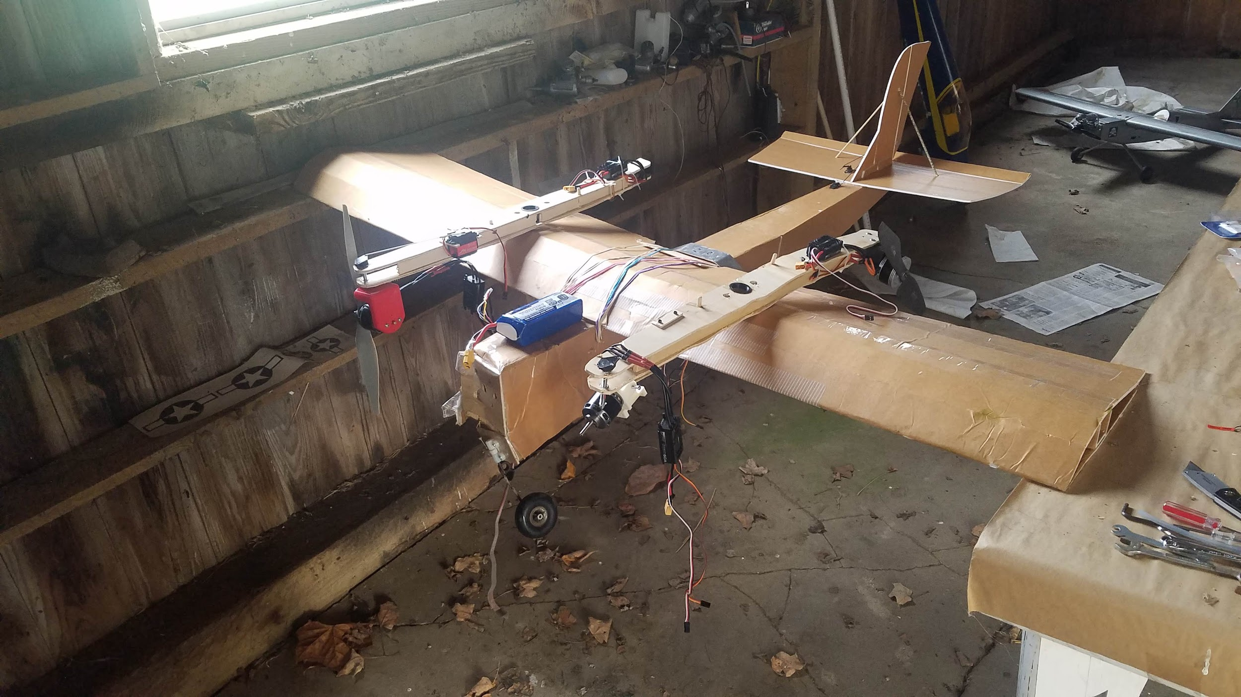

4. Prototyping fiberglass motor mounts. I expected it, but the first prototype was of terrible quality. I put one layer of glass on the top, and then starting from the bottom, I attempted to wrap the entire part, double-wrapping the bottom in the process. The net result was (or would have been) 2 layers on the top, 2 layers on the bottom, and 1 layer on the sides that went all the way around. I attempted to do all of this in one curing operation. In retrospect, it was a very ambitious way of applying multiple layers of fiberglass. This image shows the protoype with a 3d-printed swivel motor mount attached. In it, the motor mount is connected to a bag with a 10-lb weight. It initially handled forward (axial, or thrust) load just fine, but the bending load case was bad. Despite the unnacceptably-low quality, I wanted to see how it would support the bending loads it would see in-flight. Naturally, the result was terrible (as you can see below). The fiberglass buckled in compression, the polystyrene (styrofoam) foam at the “bottom” compressed, and the poor adhesion of fiberglass on the sides of the arm did nothing to help.

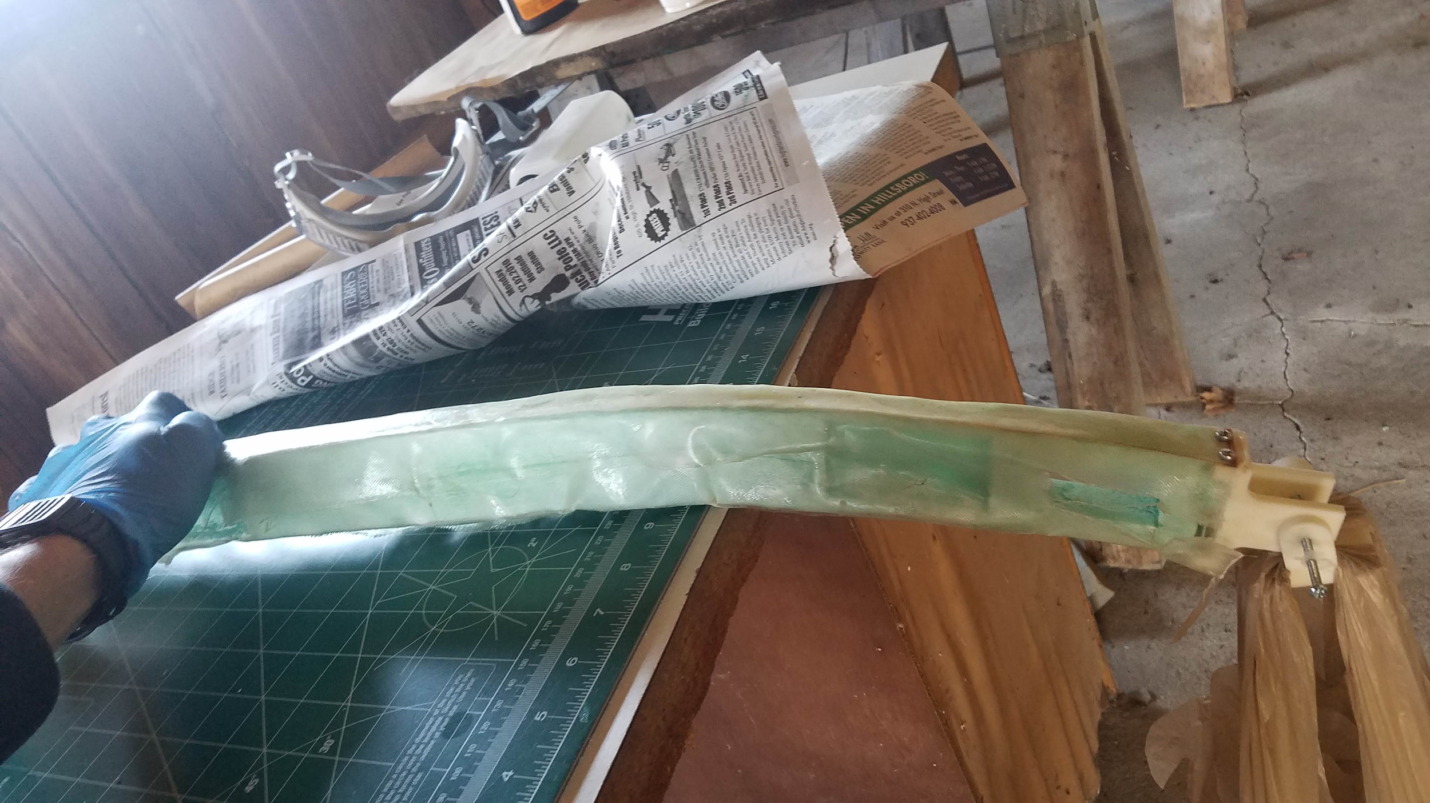

The second prototype was, in a way, a big improvement. Learning from my previous failure, I realized I wanted to simplify each curing operation to achieve higher quality. I also increased the amount of glass I planned on using. This time, I would apply 2 strips of glass on the top in one curing operation. Then, after waiting for it to cure, I would flip it over and glass the bottom (2 layers again). After waiting for that to cure, I was going to lay it on its side and apply a single layer. This side layer, however, would extend up to the top and bottom. This would connect the glass on the top and bottom together with a shear web while also adding to their own strength. Then I would do the same on the other side of the arm. The net result would be 4 layers of glass on the top and bottom with a single layer on either side acting as a shear web.

But after applying the glass on the top and the bottom, I realized there were streaks in the foam. This reminded me a lot of CA (glue) eating through polystyrene foam. That’s when I realized that polyester resin and polystyrene do not play nicely together. This had deteriorated the foam to some extent and would definitely hurt the quality of my final result.

This threw some uncertainty in how I should proceed. I figured I could:
- Try to modify the original wood “Muse” arms for use with my new motor mount arms. Those arms were heavy, of low quality, and I need to move past them anyway. I would like whatever I build to lead to a high-quality end solution. This would NOT do that for me.
- Try switching to a pure-wood or wood-reinforced foam construction. This would be cheap but lame. I’m also not sure how well it would perform.
- Just order composite rectangular tubes from a supplier and cut it to form. This option sounded attractive until I realized how expensive COTS composite rectangular tubes are.
- Invest in some good Epoxy resin and keep working on making my own part. I chose this option because it’s good experience, should drive to a fairly high-performance solution, and it’s not too expensive (although epoxy resin still is NOT cheap!).

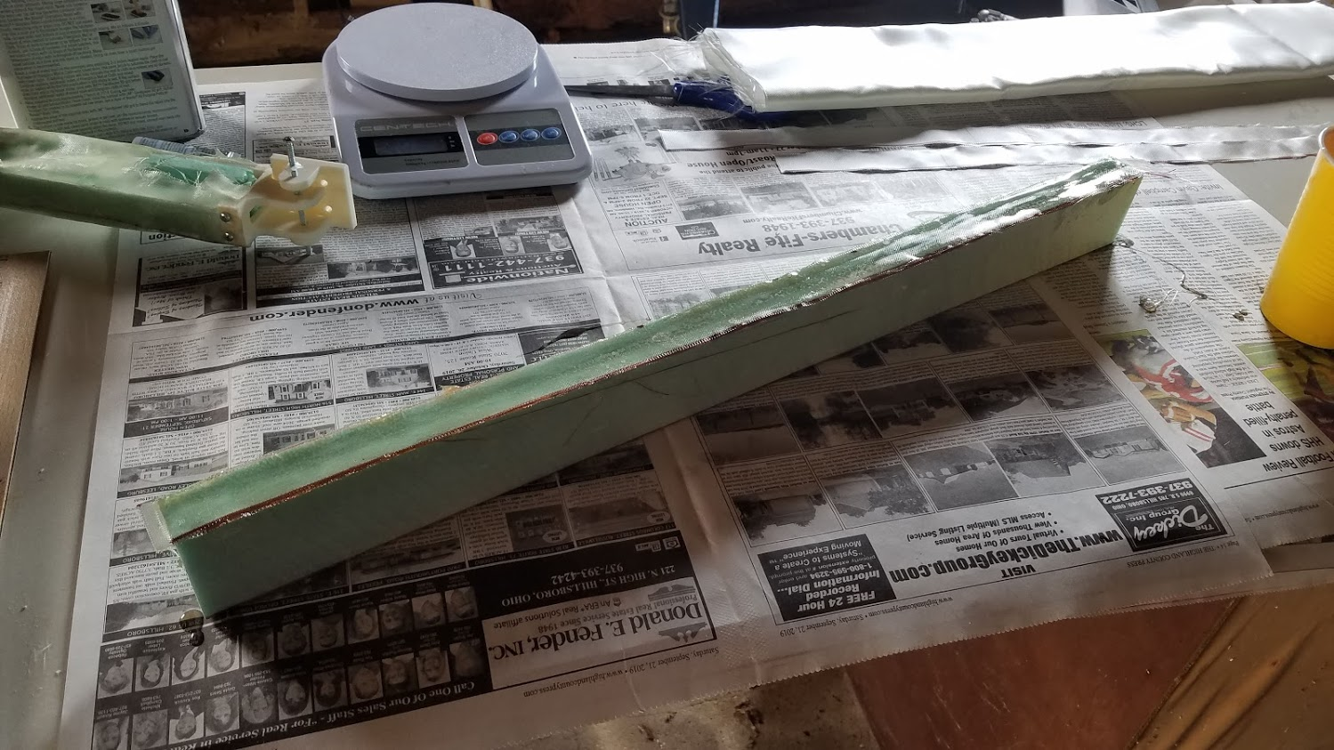

So after selecting option 4 and ordering more supplies (including epoxy resin and new fiberglass cloth/tape), I revisited the second prototype. I decided to take it to structural failure without adding the shear web (the material on the sides). I did this mostly to test the adhesion between the glass and the polystyrene foam. In theory, it shouldn’t have been very good because the resin was eating away at the foam while curing. It actually wasn’t terrible. The part took at least several pounds of load before the fiberglass on the bottom buckled, separating from the foamboard. This is what I expected.

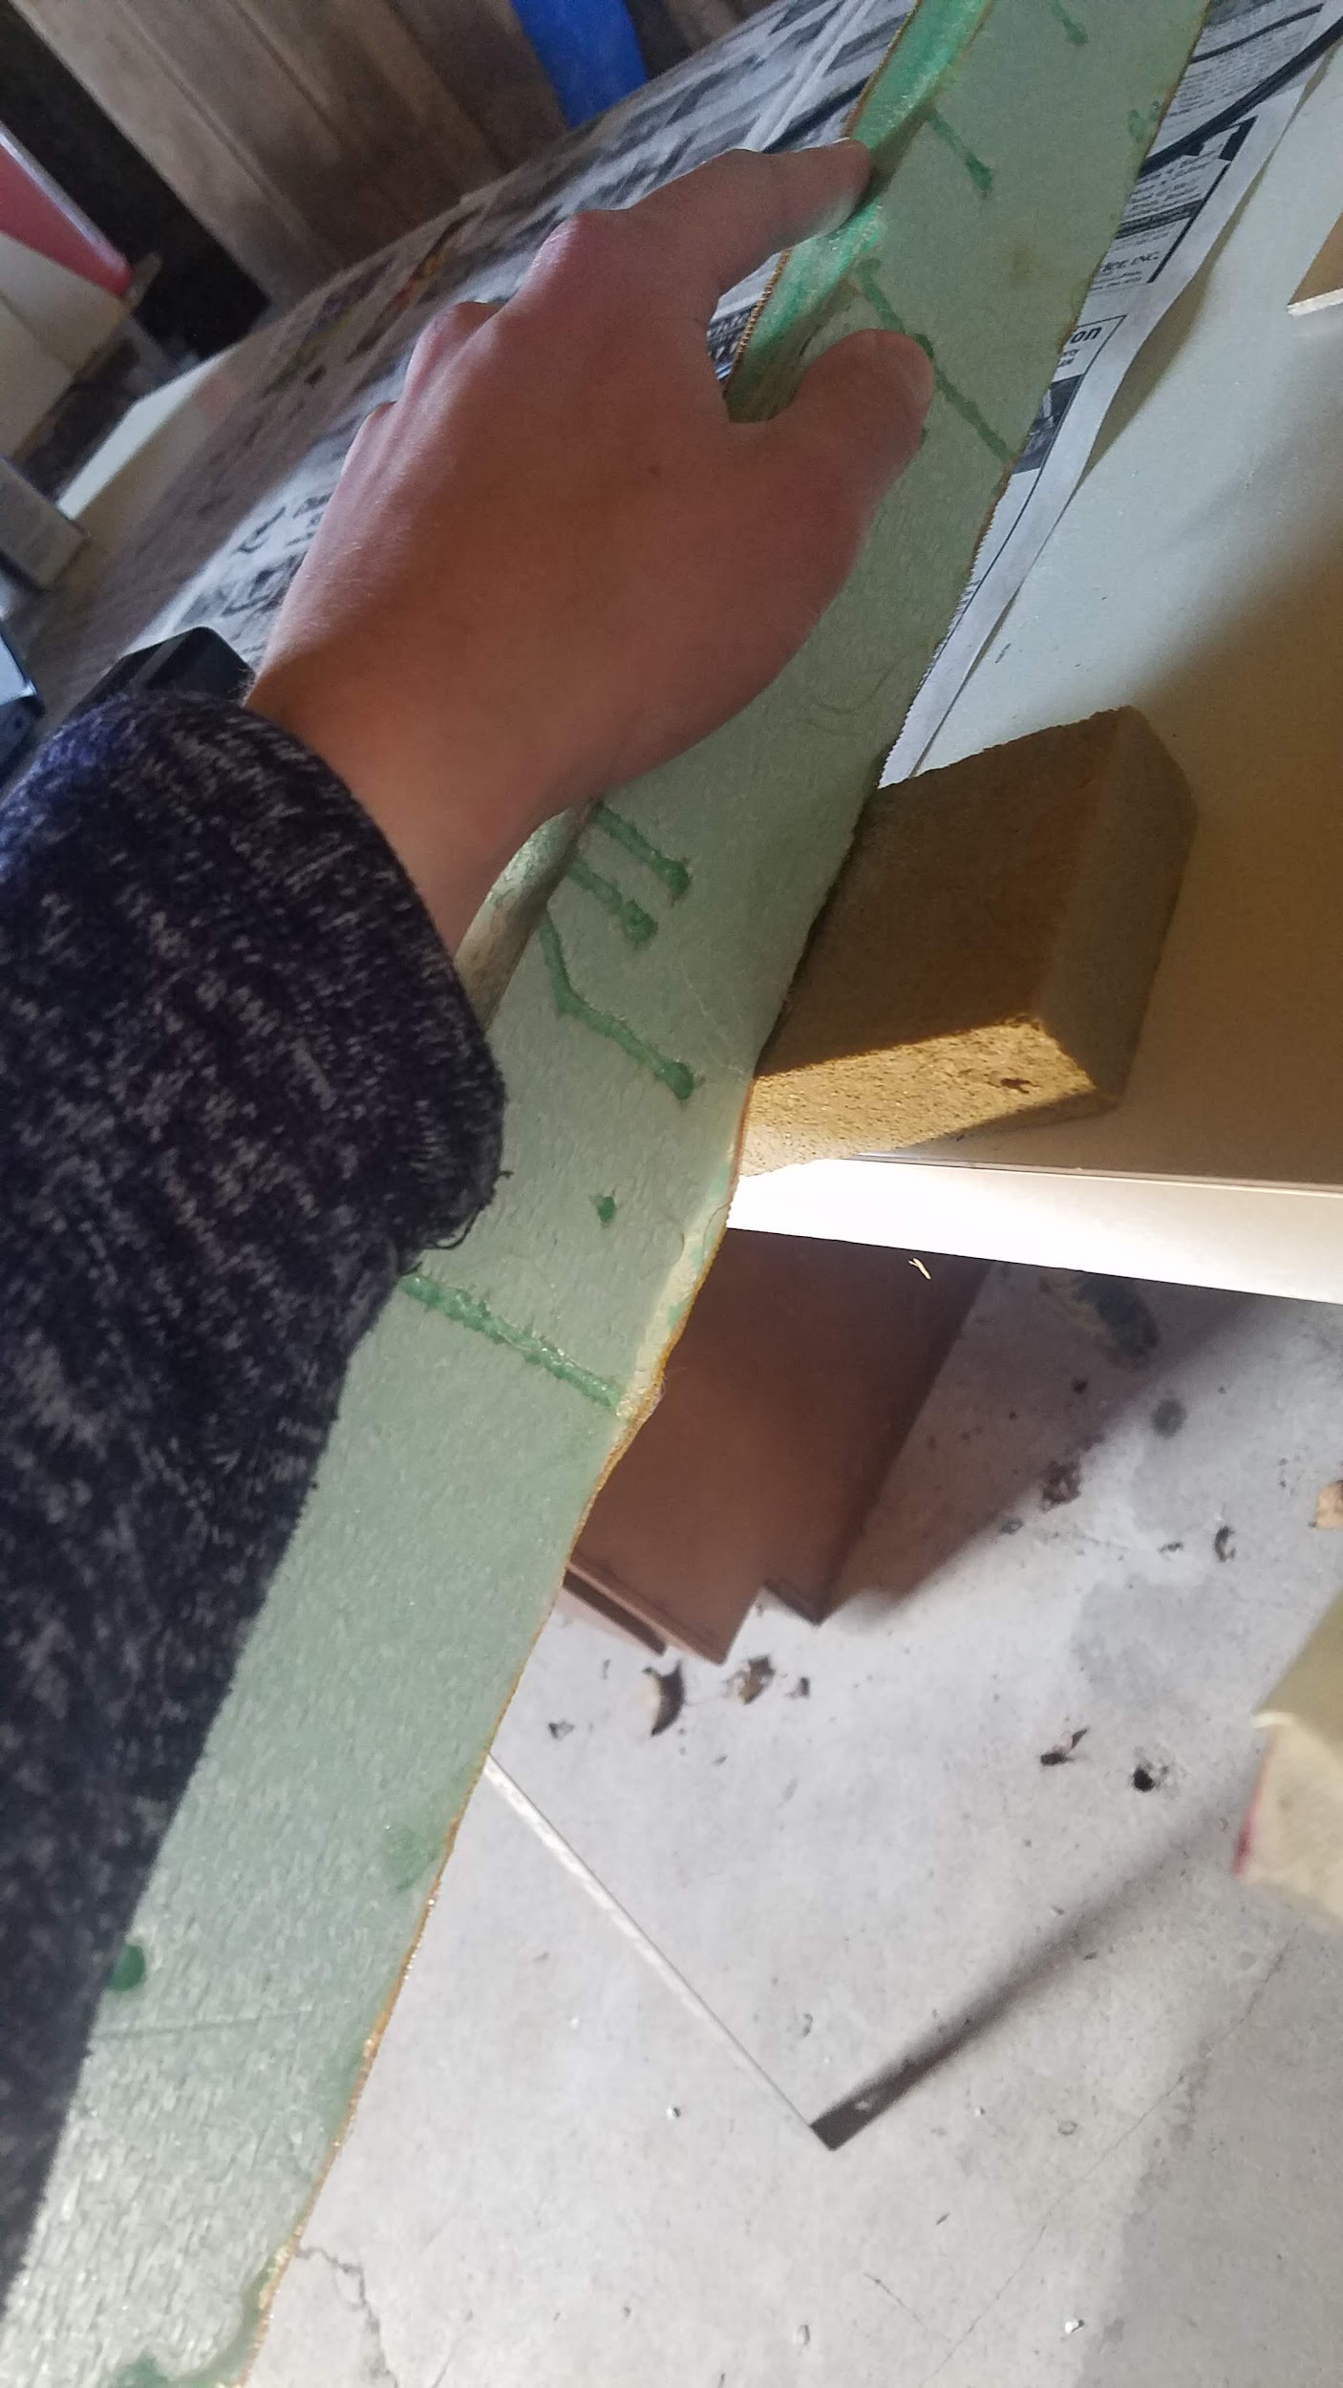
This image shows prototype 2 after destructive testing of the bending load case. The fiberglass separated from the bottom of the foam. You can also see where the resin had “eaten” away at the foam.

The resin and glass I ordered came in already, so I should be able to continue prototyping my fiberglass arms. I am very optimistic that I know how to move forward. It seems obvious by now that the styrofoam I am using is not quite sufficiently stiff to be a true foam core (and support the fiberglass with perfect efficiency), but it is far cheaper than the foam core the composites companies sell (>$50 a sheet). Good enough for my purposes.

5. Flight controller: my Spektrum satellite reciever came in today. I needed this special reciever to connect my (spektrum) transmitter directly to the pixhawk. Except an adapter, this is (hopefully) the last thing I need to get re-acquainted with the flight controller ahead of flight-testing.

